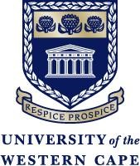

OFFICE OF THE RECTOR AND VICE-CHANCELLOR

Prof Robert J. Balfour
Rector and Vice-Chancellor
University of the Western Cape
rbalfour@uwc.ac.za
VC Draft Script for the Freedom Day Video Message, (21 April 2026)
Freedom Day takes us back to a defining moment in our country’s history. It reminds us of the beginning of democratic South Africa and of the promise of a more equal society. For UWC, that history speaks to who we are as an institution. Amid the pressures of academic life, Freedom Day asks us to slow down and consider how far we have come, and how far we still have to go. It asks whether we are living up to what was promised in 1994, and whether we are moving closer to the society we said we wanted to build.
At UWC, those questions are close to our history and purpose. This university was built by people who refused to accept things as they were. Our students and staff have long been activists and thinkers who believed that education could help change society. That conviction remains strong today. We are reminded that to be free is not merely to cast off one’s chains, but to live in a way that respects and enhances the freedom of others. Three decades of democracy have taught us that freedom requires exactly that kind of care. It grows where there is access to education and opportunity, and where people are genuinely seen and heard.
That is what we continue to build at UWC, a university where those values are present every day, and whose reach extends into the broader life of our country.

